**React Exp-9**

**Program:**

**App.js:**

import React from "react";

import ListofPlayers from "./Components/ListofPlayers";

import Scorebelow70 from "./Components/Scorebelow70";

import OddPlayers from "./Components/OddPlayers";

import EvenPlayers from "./Components/EvenPlayers";

import ListofIndianPlayers from "./Components/ListofIndianPlayers";

function App() {

  const flag=true;

  const players=[{name:"Mr.Jack",score:50},

    {name:"Mr.Michael",score:70},

    {name:"Mr.John",score:40},

    {name:"Mr.Ann",score:61},

    {name:"Mr.Elisabeth",score:61},

    {name:"Mr.Sachin",score:95},

    {name:"Mr.Dhoni",score:100},

    {name:"Mr.Virat",score:84},

    {name:"Mr.Jadeja",score:64},

    {name:"Mr.Raina",score:75},

    {name:"Mr.Rohit",score:80}];

  const IndianTeam=["Sachin1","Dhoni2","Virat3","Rohit4","Yuvaraj5","Raina6"];

  const IndianPlayers=["Mr. First Player","Mr. Second Player","Mr. Third Player","Mr. Fourth Player","Mr. Fifth Player","Mr. Sixth Player"];

  if (flag===true) {

    return (

      <div>

        <h1>List of Players</h1>

        <ListofPlayers players={players}/>

        <hr/>

        <h1>List of Players having Scores Less than 70</h1>

        <Scorebelow70 players={players}/>

      </div>

    );

  } else {

    return (

      <div>

        <div>

          <h1>Odd Players</h1>

          {<OddPlayers IndianTeam={IndianTeam}/>}

          <hr/>

          <h1>Even Players</h1>

          {<EvenPlayers IndianTeam={IndianTeam}/>}

        </div>

        <hr/>

        <div>

          <h1>List of Indian Players Merged:</h1>

          <ListofIndianPlayers IndianPlayers={IndianPlayers}/>

        </div>

      </div>

    );

  }

}

export default App;

**ListofPlayers.js**

import React from "react";

const ListofPlayers=({players})=>{

  return (

    <ul>

      {players.map((p,i)=>(

        <li key={i}>{p.name}{p.score}</li>

      ))}

    </ul>

  );

};

export default ListofPlayers;

**Scorebelow70.js:**

import React from "react";

const Scorebelow70 = ({ players }) => {

  const filtered = players.filter((p) => p.score < 70);

  return (

    <ul>

      {filtered.map((p, i) => (

        <li key={i}>{p.name} {p.score}</li>

      ))}

    </ul>

  );

};

export default Scorebelow70;

**OldPlayers.js:**

import React from "react";

const OddPlayers = ({ IndianTeam }) => {

  const odd = IndianTeam.filter((_, i) => i % 2 === 0);

  const labels = ["First", "Third", "Fifth"];

  return (

    <ul>

      {odd.map((p, i) => (

        <li key={i}>{labels[i]} : {p}</li>

      ))}

    </ul>

  );

};

export default OddPlayers;

**EvenPlayers.js:**

import React from "react";

const EvenPlayers = ({ IndianTeam }) => {

  const even = IndianTeam.filter((_, i) => i % 2 !== 0);

  const labels = ["Second", "Fourth", "Sixth"];

  return (

    <ul>

      {even.map((p, i) => (

        <li key={i}>{labels[i]} : {p}</li>

      ))}

    </ul>

  );

};

export default EvenPlayers;

**ListofIndianPlayers.js:**

import React from "react";

const ListofIndianPlayers = ({ IndianPlayers }) => {

  return (

    <ul>

      {IndianPlayers.map((p, i) => (

        <li key={i}>{p}</li>

      ))}

    </ul>

  );

};

export default ListofIndianPlayers;

**Output:**

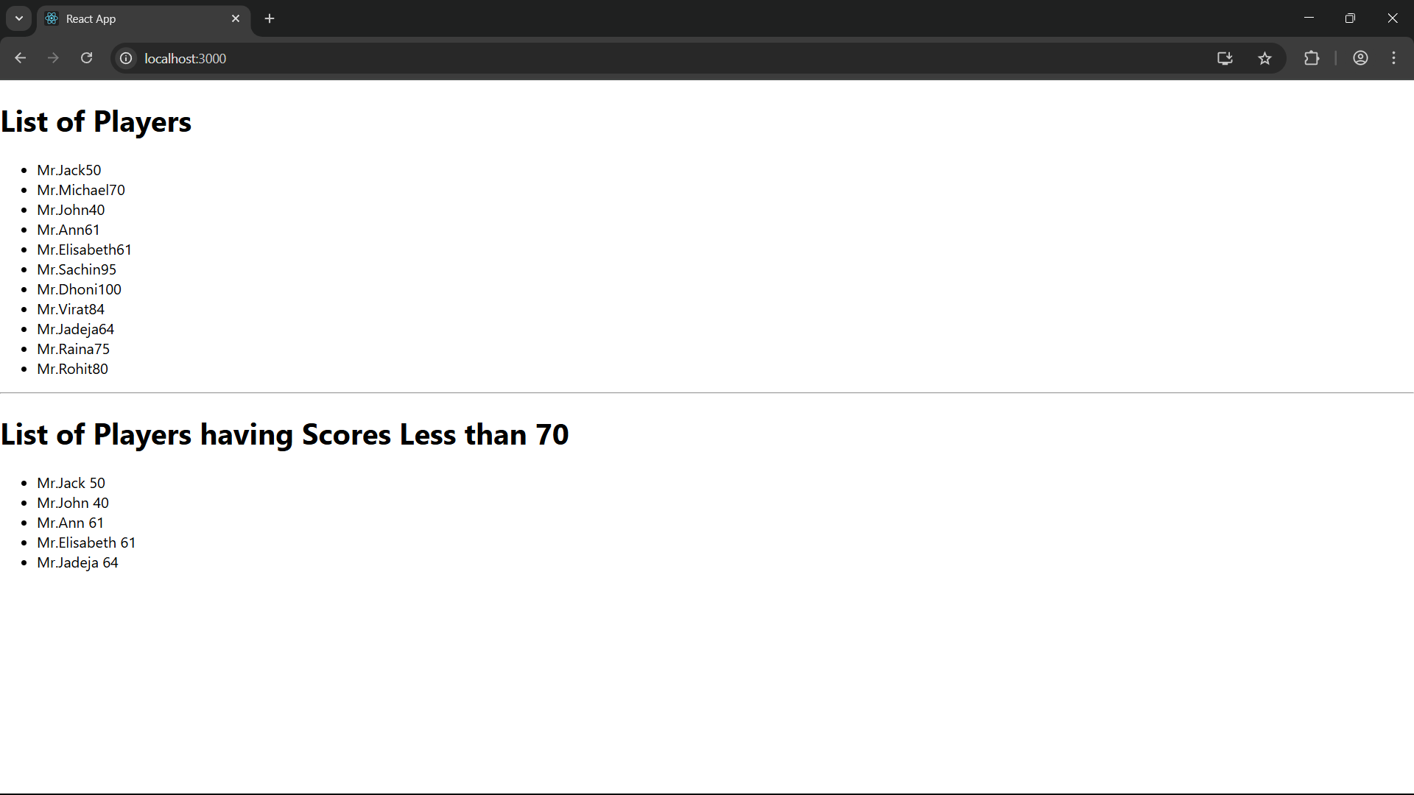

If flag is false,

